The LASAD Framework – Documentation
- Software

  - Client

The client of the LASAD framework is based upon Google Web Toolkit 2.2.0 (GWT), a framework that allows programming in Java and compilation into platform-independent JavaScript code.

  - Server

The server of the LASAD framework is written in Java and is using Remote Method Invocation to communicate with the clients (or in case of the GWT client, with the client's servlet)

  - Database

On the database layer we are using MySQL.

Guides how to setup a developer or a live environment of the system are attached in the appendix.

- External Libraries

  - Ext GWT / GXT: To extend the graphical capabilities of GWT, we use the Ext GWT / GXT library for GWT with version number 2.2.3

  - JDOM: To simplify the work with XML files, we use JDOM

  - GWTEventService: An external library to integrate server-push capability into GWT. Currently, we use it in version 1.1.1

  - Rocket GWT Framework: We use (modified) parts of the Rocket GWT Framework to enable text selections in the transcript (cf. LARGO ontology; transcript-element)

  - GWT diagrams: To integrate drawing mechanisms into GWT, we used large parts of the code of the (no longer developed) project GWT diagrams. This project is fully integrated into our framework and edited in large parts.

- The LASAD Framework

  - Client Package Structure

lasad.gwt.client | All classes that belong to the GWT client
lasad.gwt.client.communication | Everything that is important to communicate with the servlet and the server
lasad.gwt.client.constants | Support for internationalization, i.e. support for English and German language
lasad.gwt.client.helper | The complete GWT diagrams project, which is used to draw lines and curves
lasad.gwt.client.importer | Functions to import existing maps from other argumentation frameworks like ARGUNAUT and LARGO
lasad.gwt.client.logger | Logging functionality; The logs can be accessed via the DEBUG panel
lasad.gwt.client.model | Implementation of a MVC model on the client side
lasad.gwt.client.model.organization | Allows for auto organization of map with the click of a button, as well as support for “grouping” boxes
lasad.gwt.client.settings | Global settings for the whole project like DEBUG outputs, etc.
lasad.gwt.client.ui | Everything that is connected to the user interface of the client
lasad.gwt.client.ui.box | Elements that are specific to the graphical box representation of a contribution
lasad.gwt.client.ui.link | Elements that are specific to the graphical link representation of a relation
lasad.gwt.client.ui.common | Graphical elements that are common to the box and link representation
lasad.gwt.client.ui.replay | Classes related to replay functionality
lasad.gwt.client.ui.workspace | Interface related things
lasad.gwt.client.ui.workspace.argumentmap | The “white space” in which all graphical elements are integrated
lasad.gwt.client.ui.workspace.awareness | Holds all classes that are used to show other users’ cursor movements on the argument map
lasad.gwt.client.ui.workspace.chat | The chat window
lasad.gwt.client.ui.workspace.feedback | All feedback related things, including the panel in which all feedback messages are stored as well as graphical elements that are placed in the argument map
lasad.gwt.client.ui.workspace.questionnaire | All classes that are connected to the “in-system” questionnaire
lasad.gwt.client.ui.workspace.tabs | Each tab item of the system with its content
lasad.gwt.client.ui.workspace.transcript | Text that is integrated into an argument map and that can be used to link boxes or links to
lasad.gwt.client.ui.workspace.tableview | Alternative table visualization of the argument map
lasad.gwt.client.ui.workspace.tutorial | The tutorial panel that shows the text and pictures can be integrated into an ontology to learn how to argue
lasad.gwt.client.ui.workspace.userlist | A list of active users on the argument map
lasad.gwt.client.xml | Includes the mechanisms to parse XML code that is received from the server on login like, e.g., the ontology and template definition
lasad.gwt.server | The servlets that are accessed directly from the GWT client

  - Server Package Structure

lasad.database | Database-related classes (e.g. DB-Initializer)
lasad.entity | Database objects
lasad.gui | Server gui for debug messages
lasad.helper | Classes that are used by the server to outsource a couple of helper functions (e.g. MD5-encoding)
lasad.logging | Common format logger
lasad.gwt.client.communication.objects | Communication objects that are used to exchange data between clients and server

  - Client- / Server Communication

    - Architecture

Whenever an action occurs on the client, it is sent to the servlet via GWT RPC. This servlet calls the Java-Server via the remote interface method doActionOnServer. The server processes the action, stores necessary information in the database, and distributes the action to all connected clients. Therefore, a server-push servlet is used which is being notified via http-request by the server any time the clients need to get an update. Next, the servlet sends via GWT EventService (server push) new actions to their clients. The clients will then apply it to their view.

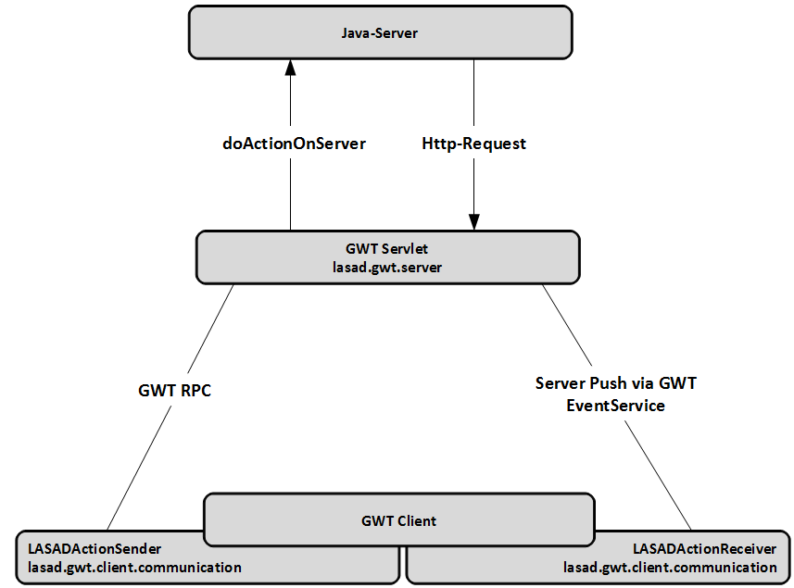
Other clients than the GWT client are able to either communicate directly with the Java-Server via RMI. This has to be announced to the server in the LOGIN action (see below. The server will check the RMI registry for a registered method named equal to the username. Thus, each external client has to register its service at the server’s RMI registry before logging in to the system. The service must implement the following interface:

package lasad;

import java.rmi.Remote;
import java.rmi.RemoteException;
import java.util.Vector;

import lasad.gwt.client.communication.objects.ActionPackage;

public interface ClientInterface extends Remote {

public void doActionPackagesOnClient(Vector<ActionPackage> vp) throws RemoteException;
}

    - Structure of communication objects

Each client action will create the following structure:

ActionPackage
Action
String: Category
String: Command
Parameter (1..n)
String: Name
String: Value

Each event that occurs in the client, will result in an ActionPackage that is sent to the server. Each ActionPackage consists of 1 to n Actions. Each Action has a category (for instance: management, map, feedback, etc.) and a command (for instance: add, delete, update) as well as a number of parameters. Each parameter is a pair of name and value.

    - List of possible actions

The following list of Actions will show the actions that are sent to the server including their parameters. However, the answer may contain additional information added by the server, e.g. server timestamps, unique IDs, etc.

Category | Description
MANAGEMENT | Deals with everything that is required to handle with the meta actions such as login, logout, etc.
MAP | Contains all actions that actually aimed to modify a concrete argument map session
COMMUNICATION | Chat messages
FEEDBACK | Feedback messages
QUESTIONNAIRE | Originally designed to deal with questions and answers of an in-system questionnaire (currently not implemented)
AUTHORING | All actions that are used to configure the system
REPLAY | Used to get all information needed for a replay of an argument map session
FILE | To load a state-based log of an argument session, i.e. an XML file generated in LASAD

Category | Command [Description] | Parameters | Description
MANAGEMENT | LOGIN [System login] | USERNAME
MANAGEMENT |  | PW
MANAGEMENT |  | METHOD | Options: “RMI” or “GWT”. If you choose RMI, your username must be the same as your client’s name in the RMI registry
MANAGEMENT | JOIN [Map session join] | MAP-ID
MANAGEMENT | LEAVE [Map session leave] | MAP-ID
MANAGEMENT | LOGOUT [System logout] | -
MANAGEMENT | LIST [List active map sessions] | -
MANAGEMENT | MAPDETAILS [Details of a concrete map session] | MAP-ID
MANAGEMENT | TEMPLATEDETAILS [Details of a concrete template] | TEMPLATE | Name of the template
MANAGEMENT | GETALLONTOLOGIESANDTEMPLATES [List the names of all ontologies and templates on the server] | -
MANAGEMENT | GETONTOLOGY [Returns the XML definition of the map’s ontology] | MAP-ID
MANAGEMENT | CREATEANDJOIN [Creates a new session and joins it] | MAPNAME | Name of the map session that should be created
MANAGEMENT | CREATEANDJOIN [Creates a new session and joins it] | TEMPLATE | Name of the template
MANAGEMENT | GET-TEMPLATES [List all active templates] | -
MAP | CREATE-ELEMENT [Creates a new element. An element can either be a top-level element such as box and relation or sub-level elements such as text, rating, etc. Additional elements can be feedback clusters, cursors, etc] | PARENT | Used to connect a new element to an existing one. For instance to add a text field to a box. However, there might be two parents, e.g. in the case of a relation
MAP |  | MAP-ID
MAP |  | TYPE | The type of the newly created element that is defined in the ontology
MAP | UPDATE-ELEMENT [Change the state of an existing element] | ID | Unique ID of the element that should be updated
MAP | UPDATE-ELEMENT [Change the state of an existing element] | MAP-ID
MAP | DELETE-ELEMENT [Delete a specific element] | MAP-ID
MAP | DELETE-ELEMENT [Delete a specific element] | ID
MAP | UPDATE-CURSOR-POSITION [Updates the awareness cursor] | PERSISTENT | Indicates if the update should be saved as new revision to be replayed or not
MAP | UPDATE-CURSOR-POSITION [Updates the awareness cursor] | ID
MAP | UPDATE-CURSOR-POSITION [Updates the awareness cursor] | MAP-ID
MAP | UNDO | -
FEEDBACK | REQUEST [Distribute a feedback request to all connected clients] | MAP-ID
FEEDBACK | CREATE-ELEMENT [Creates a new feedback cluster which is used to give feedback] | MAP-ID
FEEDBACK |  | TYPE | For the feedback the type should be “feedback-cluster”
FEEDBACK |  | MESSAGE | The feedback text
FEEDBACK |  | HIGHLIGHT-ELEMENT-ID | The unique IDs of the elements that should be highlighted in this cluster
QUESTIONNAIRE | - | -
AUTHORING | GET-TEMPLATES [List all active templates] | -
AUTHORING | CREATE-TEMPLATE [Creates a new template] | TEMPLATE-NAME
AUTHORING | CREATE-TEMPLATE [Creates a new template] | ONTOLOGY-NAME
AUTHORING | CREATE-TEMPLATE [Creates a new template] | TEMPLATE-DESCRIPTION
AUTHORING | CREATE-TEMPLATE [Creates a new template] | MAX-USERS | Maximum number of users participating actively on a map session
AUTHORING | CREATE-TEMPLATE [Creates a new template] | USE-CHAT | Enable (TRUE) / Disable (FALSE) the chat window
AUTHORING | CREATE-TEMPLATE [Creates a new template] | USE-USERLIST | Enable (TRUE) / Disable (FALSE) the list of active users
AUTHORING | CREATE-TEMPLATE [Creates a new template] | USE-CURSOR-TRACKING | Enable (TRUE) / Disable (FALSE) the cursor-tracking
AUTHORING | CREATE-TEMPLATE [Creates a new template] | USE-SELECTION-DETAILS | Enable (TRUE) / Disable (FALSE) an additional panel for showing hidden child-elements of a top-level element
AUTHORING | CREATE-TEMPLATE [Creates a new template] | TRANSCRIPT | A given internal text that can be used for argumentation
AUTHORING | DELETE-TEMPLATE [Removes a template] | TEMPLATE | Name of the template that should be deleted
AUTHORING |  | CONFIRMED | TRUE / FALSE: Used to force the server to delete it instead of asking once again if the user is sure
AUTHORING | GET-ONTOLOGIES [List all active ontologies] | -
AUTHORING | GET-ONTOLOGY-DETAILS [Returns XML definition based on the ontology’s name] | ONTOLOGYNAME | Name of the ontology
AUTHORING | CREATE-ONTOLOGY [Creates a new ontology] | ONTOLOGY-XML | The XML definition of the ontology
AUTHORING | CREATE-ONTOLOGY [Creates a new ontology] | ONTOLOGYNAME | Name of the ontology
AUTHORING | DELETE-ONTOLOGY [Deletes an existing ontology] | ONTOLOGYNAME | Name of the ontology
AUTHORING | DELETE-ONTOLOGY [Deletes an existing ontology] | CONFIRMED | TRUE / FALSE: Used to force the server to delete it instead of asking once again if the user is sure
AUTHORING | UPDATE-ONTOLOGY [Changes the ontology definition of an existing ontology] | ONTOLOGYNAME | Name of the ontology that should be updated
AUTHORING |  | ONTOLOGY-XML | The updated XML definition of the ontology
AUTHORING | GET-MAPS-AND-TEMPLATES [Lists all map sessions and templates] | -
AUTHORING | CREATE-MAP [Creates a new map session] | MAPNAME | Name of the new map session that should be created
AUTHORING | CREATE-MAP [Creates a new map session] | TEMPLATE | Name of the template that is underlying the map session
AUTHORING | CREATE-MAP [Creates a new map session] | RESTRICTED-TO | Name of the user the session should be restricted to
AUTHORING | DELETE-MAP [Deletes an existing map session] | MAPNAME | Name of the map session that will be deleted
AUTHORING | GET-USERS [List all users that are stored in the system] | -
AUTHORING | CREATE-USER [Creates a new user] | USERNAME
AUTHORING | CREATE-USER [Creates a new user] | PW
AUTHORING | CREATE-USER [Creates a new user] | ROLE | Name of the role the new user should have
AUTHORING | DELETE-USER [Deletes an existing user] | USERNAME | Name of the user that should be deleted
AUTHORING | DELETE-USER [Deletes an existing user] | CONFIRMED | TRUE / FALSE: Used to force the server to delete it instead of asking once again if the user is sure
REPLAY | - | MAP-ID
FILE | - | ONTOLOGY-XML | The ontology XML definition
FILE | - | TEMPLATE-XML | The template XML definition
FILE | - | CONTENT-XML | The concrete content of the new session
FILE | - | SESSION | Name of the new map session that should be created based on the XML file

  - Configuration Mechanisms

    - Interface

The following interface elements are configurable and can be dynamically (de-)activated:

- Chat

The chat will appear on the right-hand side. It can be combined with every other interface element.

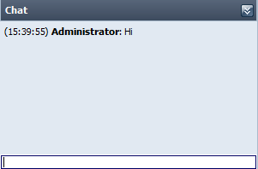

- List of active map users

Showing all users that are currently active on the map.

- Tutorial

The tutorial can be used to explain the use of the system or to integrate the task description into the system. It consists of multiple steps. The number of steps is not fixed. However, you should take care that there are not too many steps because the open step panels will use the space left.
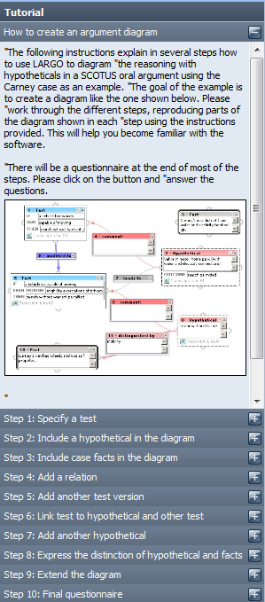

- Transcript / Internal text

Used for instance in the LARGO ontology. Here, a given text can be integrated into the system. You can link this text to contributions (not relations). Then, the text will be highlighted in the color of the contribution. Selection is only line-wise possible. Each line is internally a DIV, so take care not to use too many lines. However, 100-200 are fine.
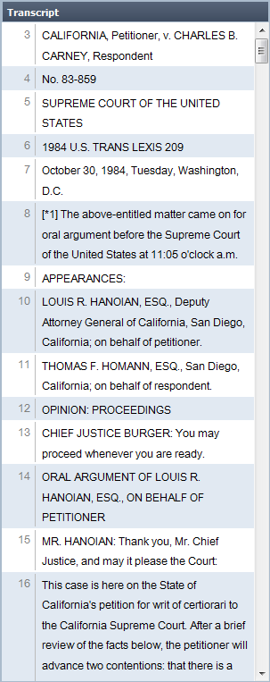

- Panel showing (hidden) details of a box (SelectionDetailsPanel)
- Feedback window
- Cursors of other users

    - Top-level elements

The following top level elements are available to model an argument:

- box

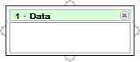

- relation

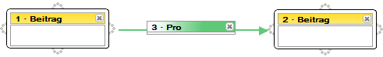

Relations can go from a box to another box or to a relation. Each relation is configurable. More concrete, the configuration options are:

elementoptions:
  - endings = true | false
  - heading = [Text of the relation]

uisettings:
  - width = width of the panel
  - resizable = true | false
  - background-color = [Color of the panel]
  - linecolor = [Color of the line / curve]
  - linewidth = [width of the line in px]

Here is an example of the configuration of the pro relation above:
<element elementid="prolink" elementtype="relation">
<elementoptions heading="Pro" endings="true" />
<uisettings width="112" height="100" resizable="false" background-color="#5FC977" linewidth="2px" linecolor="#5FC977" />
<childelements>
…
</childelements>
</element>

Each of these elements can have a set of sub-level elements. The number of sub-level elements is not restricted. The top-level elements are not required to be rendered in a graph-style, but can be rendered in different visualizations (like for instance a table) as well.

    - Sub-level elements

- text
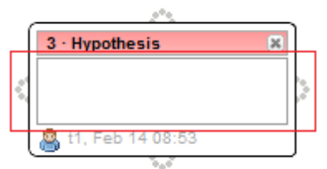
A simple text field a user can edit

elementoptions:
  - text = [Text]

uisettings:
  - minheight = [Minimum height of the text field]
  - background-color = [Color of the background]
  - fontcolor = [Color of the letters]

Here is an example of the configuration of the text elemen above:
<element elementid="text" elementtype="text" quantity="1"
minquantity="1" maxquantity="1">
<elementoptions text="" />
<uisettings minheight="26" />
</element>

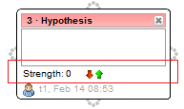
- score
With the score (or rating) element the user can set a certain strength to a hypothesis, fact,.... It's usable in relations either.

elementoptions:
  - label = [Label text, e.g. “Strenght:”]
  - score = [Initial score value]
  - minscore = [Minimum score value]
  - maxscore = [Maximum score value]

uisettings:
  - minheight = [Minimum height of the score field]
  - maxheight = [Maximum height of the score field]
  - background-color = [Color of the background]
  - fontcolor = [Color of the letters]

Here is an example of the configuration of the score element above:
<element elementid="strength" elementtype="rating" quantity="1"
minquantity="0" maxquantity="1">
<elementoptions label="Strength" score="0" minscore="-10" maxscore="10" />
<uisettings minheight="15" maxheight="15"/>
</element>

- url
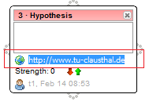
The url element displayes a url which can be edited by the user. Of course, users can click on it to call that url in a new browser window.

uisettings:
  - minheight = [Minimum height of the score field]
  - maxheight = [Maximum height of the score field]
  - background-color = [Color of the background]
  - fontcolor = [Color of the letters]

Here is an example of the configuration of the url element above:
<element elementid="url" elementtype="url" quantity="1"
minquantity="0" maxquantity="1">
</element>

- transcript-link

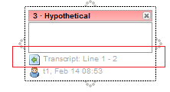
The transcript-link element displays a connection to a certain passage within the transcript. In the transcript, this connection is displayed by marking that passage with the box's default representation color and the functionality to center the connected box when clicking the corresponding text passage. In this case the transcript would look like this:

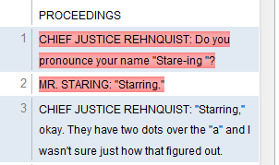

elementoptions:
  - manualadd = true | false
  - longlabel = [Text]
  - startrow = [startrow value]
  - endrow = [endrow value]
  - startpoint = [Startpoint value]
  - endpoint = [Endpoint value]

uisettings:
  - minheight = [Minimum height of the score field]
  - maxheight = [Maximum height of the score field]

Here is an example of the configuration of the transcript-link element above:
<element elementid="transcriptlink" elementtype="transcript-link" quantity="0"
minquantity="0" maxquantity="1">
<elementoptions manualadd="false" longlabel="Transcript-Link" startrow="1"
emdrow="2" startpoint="0" endpoint="0" />
<uisettings minheight="16" maxheight="16"/>
</element>

- awareness
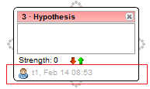
The awareness element is used to display certain information about the element itself, which are the author (creator) of that element (box, relation) and the creation time

elementoptions:
  - text = [Text]

uisettings:
  - minheight = [Minimum height of the awareness field]
  - maxheight = [Maximum height of the awareness field]
  - background-color = [Color of the background]
  - fontcolor = [Color of the letters]

Here is an example of the configuration of the awareness element above:
<element elementid="awareness" elementtype="awareness" minquantity="1" maxquantity="1">
<elementoptions text="t1, Feb 14, 08:53" />
<uisettings minheight="16" maxheight="16"/>
</element>

- dropdown

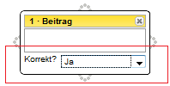
The drop down box provides a certain amount of elements the user can choose from.

elementoptions:
  - Label = [Text]
  - options = {[Text],[Text],...]
  - selectedoption = Leer oder [Text] (muss in options enthalten sein)

uisettings:
  - minheight = [Minimum height of the awareness field]
  - maxheight = [Maximum height of the awareness field]

Here is an example of the configuration of the dropdown element above:
<element elementid="dropdown" elementtype="dropdown" quantity="1"
minquantity="1" maxquantity="1">
<elementoptions label="Korrekt?" options="Ja,Nein" selectedoption="Ja"/>
<uisettings minheight="22" maxheight="22"/>
</element>
- URL Display

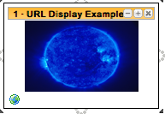

An element that allows displays the web page referenced by a URL inside the element. In addition, image URLs (ending with “.jpg, .jpeg, .png, .bmp” extensions) are scaled to the size of the element, and their aspect ratio is maintained. Double-clicking on the image will offer a larger view of the image, with size designated by “Window height and Width” (see below).
uisettings:
  - minheight = [Minimum height of the awareness field]
  - maxheight = [Maximum height of the awareness field]
  - windowhieght = [height of window that appears for images]
  - windowwidth = [width of window that appears for images]
  - defaulturl = [URL that should be displayed by the element when it is created]

Here is an example of the configuration of the dropdown element above:

<element elementtype="frame" elementid="url-view-box" minquantity="1" maxquantity="1" quantity="1">
<elementoptions/>
<uisettings windowheight="400" windowwidth="400"
defaulturl="http://www.nasa.gov/images/content/197366main_image_feature_736_946x710.jpg
" editable="true" minheight="100"/>
<childelements/>
</element>

- Radio Button

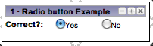

An element that provides several options to the user, of which only one can be chosen at a time. One can have either two or three options per an element

elementoptions:
  - Label = [Text]

uisettings:
  - minheight = [Minimum height of the awareness field]
  - maxheight = [Maximum height of the awareness field]

Here is an example of the configuration of the Radio element above:
<element elementtype="radiobtn" elementid="yes-no-radio" minquantity="1"
maxquantity="1" quantity="1">
<elementoptions label="Correct?"/>
<radiobuttonitems>
<radiobuttonitem id="980687281" label="Yes" checked="1"/>
<radiobuttonitem id="522326642" label="No" checked="0"/>
</radiobuttonitems>
<uisettings width="212" maxheight="30" minheight="30"/>
<childelements/>
</element>

http://code.google.com/intl/de-DE/webtoolkit/
http://www.sencha.com/products/gwt/download.php
http://www.jdom.org/
http://code.google.com/p/gwteventservice/
http://code.google.com/p/rocket-gwt/
http://code.google.com/p/gwt-diagrams/
The parameters are meant to be sent from the client’s side. Further, there might be optional parameters (partly shown in italics). The optional parameters depend sometimes on the context. Thus, they are not mentioned completely here. The server response may have additional parameters such as unique IDs or server timestamps. These are not mentioned here.
Currently not implemented
Currently not implemented

